

**Negative inflation: the implications for monetary policy**

Based on a presentation given by

Ian McCafferty, External Member of the Monetary Policy Committee, Bank of England

EBEA Teachers and Students Conference, London 11 June 2015

I would like to thank David Copple and Marilyne Tolle for their help in preparing this speech. The views expressed are my own and do not necessarily reflect those of the other members of the Monetary Policy Committee.

# Introduction

I am sure you have all seen the headlines: the UK economy is currently experiencing negative inflation for the first time since 1960. Inflation fell to -0.1% in April and is likely to remain around zero through the summer, well below the Monetary Policy Committee’s (MPC) target of 2.0%. As a result, the Governor has now had to write two open letters to the Chancellor of the Exchequer on behalf of the Committee, explaining why inflation has undershot by so much, and setting out how the MPC intends to respond.

Also widely reported in the media last week was our decision not to change the stance of monetary policy. In fact, the MPC has not voted to change Bank Rate or adjust our quantitative easing programme since 2012. Yet in the face of low and falling inflation the MPC might be expected to loosen policy. So why haven’t we? Today I would like to take you through the thinking that has motivated us not to change the policy stance in response to this deviation of inflation from the target, before setting out how we see the economy, and the rate of inflation, over the next few years, and the implications for future monetary policy.

The objective of the MPC, set by the Bank of England Act 1998, is to maintain price stability and, subject to that, to support the economic policy of Her Majesty’s Government, including its objectives for growth and employment. The remit for the MPC, given to us by the Chancellor and renewed annually, defines price stability as a 2% annual rise in the Consumer Price Index (CPI), a representative basket of goods and services consumed by households.

There are three features to which I would like to draw your attention.

* The target is symmetrical. The MPC is to treat positive and negative deviations from the inflation target equally.
* The target applies at all times. This means that even in periods when the economy is hit by inflationary or disinflationary shocks, the remit still applies and the objective of the MPC is to bring inflation back to 2%. Under such conditions, the MPC has to decide and communicate the appropriate horizon at which it is optimal to bring inflation back to the target.
* The MPC’s primary objective is to hit the inflation target, but it needs to take care that in doing so, it does not generate undue instability in output and employment. In other words, the remit allows the MPC to use its discretion to take account of output and employment conditions when determining how quickly inflation should be returned to the target.

Of course, in practice, economic shocks, emanating from both here in the United Kingdom and abroad, regularly push us away from the inflation target. So these three elements are a useful guide to determine how the MPC should respond to such shocks as they occur.

Now, not all shocks are equal, nor is it equally appropriate to use monetary policy to address them. The source and duration of the shock are important, in particular whether the shock is temporary or more persistent.

For monetary policy, temporary shocks are those that have a one-off impact on the *level* of the consumer price index. They arithmetically affect the rate of inflation for the following year, but after that, the impact on the rate of inflation disappears again. An example of this type of shock would be the increase in

Value-Added Tax in 2011; this pushed up the level of many prices and so contributed to an increase in inflation for the following year, but then fell out of the calculation a year later. Other examples would be a cut in excise duties or other taxes, or a one-off shift in the level of global commodity prices.

The economy can also be hit by more persistent shocks or forces. These continue to affect not only the level of prices but also the inflation rate for a prolonged period. One example would be the dislocation of the economy following the financial crisis, which has weighed on demand and inflation for a number of years.

Another would be the entry of China into the global marketplace in the 1990s; the emergence of such a new large low-cost producer lowered the cost of manufactured goods globally, reducing the prices of imports into the United Kingdom over a prolonged period, and thus provided a persistent downdraft to the inflation rate.

In terms of returning inflation to target, temporary shocks are less amenable to changes in monetary policy. Monetary policy works with a lag; it probably has its maximum effect on the economy somewhere between 18 and 24 months after the policy change is implemented. So any deviations in inflation from a temporary shock will have faded away by the time monetary policy is having its largest effect.

What sort of shocks are we facing today?

A number of factors are currently driving inflation away from the target. In our recent letters to the Chancellor, we identified four: the oil price, food prices, movements in the exchange rate and rates of wage growth. Let’s briefly examine each of these.

*Oil prices*

Since last summer the price of oil has fallen sharply, from a high of $115/bbl in June 2014 to a low of

$45/bbl in January 2015, before recovering to around $62/bbl last week. Oil is an important input for the economy and this fall in the price will pull down on inflation in several ways. Primarily, it will mean that the price of fuel at the pump will fall. As the Office of National Statistics includes petrol and diesel as one of the items in the CPI basket of goods, this will pull down directly on measured inflation. But oil also feeds into the cost of production and transportation of many other goods. So when the price falls, the costs of production will fall for a wide variety of goods. As costs fall, so should prices, as competition encourages firms to lower prices.

*Food prices*

Two forces have been driving food prices down recently. First, global commodity prices have weakened, as a result of trends in planting decisions and the weather. Second, you might have noticed the intense competition between supermarket chains in the United Kingdom, as the structure of the grocery market adapts to new low-cost entrants. Together, these have reduced food prices by 3% over the past year.

*Movements in the exchange rate*

Since the start of last year, the sterling exchange rate index, which is a weighted index of sterling against a range of other currencies, has appreciated by around 7%. In bilateral terms, the pound has appreciated against the euro and depreciated against the dollar.

Both of these bilateral exchange rates are important for UK inflation. Many global commodities, such as oil, and globally traded goods, such as electronic components, are traded in dollars. The

sterling-euro exchange rate is important, not just because the euro area is our largest trading partner, but because we trade a large amount of food with the continent. A pound is now worth more euros so the effective sterling price of imports from the euro area has fallen.

An increase in the sterling exchange rate affects inflation through two channels; first, the price of imported final goods and services that we import will be lower than otherwise. Second, there will be an indirect effect from imported goods that are inputs into domestic production.

These three factors have something in common – in inflation terms, they are essentially temporary shocks.

They are largely price level shocks, which should raise the inflation rate temporarily and then fade, such that much of their impact will dissipate within the monetary policy horizon, that is the 18-24 months that we think it takes monetary policy to have its peak impact on the economy. They might not have completely dissipated by then – the timing of the impact of a change in the exchange rate is particularly uncertain – but the vast majority of the impact is likely to fade over the next year. That means that if monetary policy were to respond now to these factors, by the time the effect of our policy change was fully felt, their impact would already have fallen out of the inflation calculation.

But what of the fourth factor – the weakness of wage growth? Over the last couple of years, this has been a more persistent influence.

Compared with the period before the financial crisis, wage growth has been particularly weak in recent years. Annual wage growth averaged around 4% over the period 2001-2007; since 2008, it has averaged only half that.

At its root, much of the recent weakness of wage growth can be attributed to the level of spare capacity in the economy. When the economy is operating at less than full capacity – with higher than equilibrium levels of unemployment and capacity within firms standing idle – there will be downward pressure on wages (and hence prices). As unemployment falls and companies find it harder to recruit new workers, or need to expand their operations to meet demand, wage pressures are likely to intensify.

The economy has staged a strong recovery over the past 18 months, such that much of the spare capacity evident at the end of the recession has been reabsorbed. Nevertheless, our central estimate suggests that as of the second quarter of 2015, there remained a small amount of spare capacity, concentrated in the labour market.

At the Bank, we track the level of spare capacity along four dimensions: within firms, and in three dimensions within the labour market – gaps in unemployment, average hours and labour participation; that is to say differences between the prevailing level of those variables and their equilibrium values. Spare capacity within firms is currently assessed as close to normal, so that such spare capacity as there is sits within the labour market.

* The unemployment rate – where is it in relation to what we estimate to be full employment? Having risen to over 8% during the crisis, unemployment has fallen sharply over the recovery, to 5.5% over the three months to March, still slightly higher than the MPC’s assessment of its medium term equilibrium rate, of close to 5%.
* The labour participation rate refers to the proportion of the population aged 16 or over who are either in employment or actively looking for work. Participation also fell sharply following the recession but rose as the economy recovered, although this masks substantially different experiences across age groups. We think that it is unlikely that there is very much slack left from this source.
* The average number of hours worked by employees fell sharply during the recession. Although they have since risen strongly from their trough, surveys still suggest that some workers wish to work more hours than they currently do; their desired hours are higher than their actual hours. This leads the MPC to believe that there is some slack remaining in this component.

Together, these three gaps yield an estimate of the amount of spare capacity in the labour market. While it is clear that this has declined sharply in the past couple of years, there remains a small output gap, of

somewhere around ½% of GDP. That estimate is subject to considerable uncertainty, and the margin for error is quite wide.

Nevertheless, to the extent that a small output gap still exists, it is likely to have exerted some downwards pressure on wage growth.

What does this mix of inflation shocks – some temporary, some more persistent – imply for the appropriate stance of UK monetary policy?

Although the divergence between the current rate of inflation and our 2% target is very marked, we calculate that, taken together, oil prices, food prices and other goods prices (many of which will be affected by movements in the exchange rate) – in inflation terms, the temporary, one-off price level shocks – account for about three quarters of the difference between the current inflation rate and the 2% target. The remaining quarter is due to more persistent factors, and in particular the recent weakness of wages.

As such, the current very low rate of inflation is not likely to last. In our latest forecast, we expect that the period of low inflation will start to end as we head towards the end of this year, and that by the end of 2016, it will have risen further, to 1.7%, only a little below our 2% target. As a result, we judge it appropriate not to have loosened policy in response to these shocks.

In the very near term, the risks around that inflation profile probably lie slightly to the downside. With inflation having fallen falling sharply, and expected to remain close to zero for some months yet, the MPC identified a risk of behavioural changes amongst consumers, employers and employees, that, if it transpired, would make the inflation undershoot deeper, or more persistent. This would be of concern to the Committee, and would justify a more active policy response.

The most extreme version of these behavioural changes would be the onset of deflation. True deflation is not the same as the slight fall in prices over the year to April, as it encompasses several characteristics that are lacking at the moment.

* First, the fall in prices has to be sustained and entrenched – not a slight dip that occurs for just a month or two – to be classified as deflation.
* Second, true deflation involves widespread falls amongst the CPI components. This is not the case currently. Excluding food and energy, the proportion of the components of the CPI currently showing positive inflation is much the same as it was during the decade between 1997-2007 (at 62% compared with 67%).

So, just as inflation is a widespread and persistent increase in prices, deflation is a widespread and persistent fall in prices.

But ultra-low inflation, short of true deflation, even initially caused by temporary shocks, can lead to a persistent inflation undershoot. How would this happen? Primarily, it would involve a de-anchoring of inflation expectations; that, observing slightly falling prices now, people started to expect prices to fall further in the future. Such a movement in expectations could affect price, wage and consumption decisions.

If price setters believed that prices were to continue to fall in the future, they might cut their own prices now, or at least postpone price increases. Similarly, employers might offer lower nominal wage increases.

Workers might accept lower wage increases if they believed their real spending power was protected by price deflation. And if consumers started to postpone spending because they believed that prices would be lower in the future, that would contribute to a slowing of demand. Each of these would combine to make the fall in prices self-fulfilling, and deflation would set in.

With prices falling, the real value of debt would increase, making it harder for companies and households to meet debt repayments, forcing them to cut back on investment and consumption, worsening the deflation.

However, I can reassure you – none of these behavioural changes are apparent at present, such that, while the period of ultra-low inflation is expected to persist for several more months, the near term downside risks are diminishing. Company and household inflation expectations have both fallen a little, but remain consistent with the inflation target, and a high proportion of households think that it is a good time to undertake large purchases. There are few signs of increases in financial stress due to debt affordability and the ratio of household debt to income has continued to fall.

True deflation is dangerous but rare. If we thought that there was a risk of this taking hold, we would need to respond with easier monetary policy, for once deflation sets in, it is difficult to reverse. But while temporary factors remain the principal force pushing inflation away from target, a policy response is not required, and that is why, in the face of the lowest rate of inflation in over fifty years, the MPC has voted not to loosen policy in recent months.

# The outlook for the economy and monetary policy

But how quickly is inflation likely to return to target? That will depend on the underlying performance of the economy over the next couple of years.

Last month, the MPC released its latest quarterly *Inflation Report* setting out our forecast of how we expect the economy to perform.

Our central forecast indicates that, over the next three years, the expansion of the UK economy should continue. GDP growth is expected to be at or just a little below historical average rates. Growth will be driven primarily by domestic demand. Consumers will see some improvement in their real incomes, helped in the near term by lower energy and food prices and further out by improvements in labour productivity and wages. This should help drive healthy growth in consumer spending. On the investment side we should see a pickup in housing market activity and strong business investment growth. Offsetting that, fiscal consolidation will continue to act as a headwind.

Growth in the global economy is expected to pick up slightly, with somewhat stronger growth in the euro area offset by some softness in emerging markets, particularly China, but we expect little net contribution to GDP growth from the external sector. The biggest risks that we identify to the UK growth outlook stem from international issues - most obviously from a disorderly conclusion to the debt negotiations in Greece, but also from potentially slower growth in China, and some economic instability in other emerging market economies too.

The outlook for inflation is shaped by the confluence of two factors – the speed with which the temporary shocks from oil, food and the exchange rate disappear, and how quickly the remaining spare capacity in the economy is absorbed, such that the current depressant effect on costs and wages fades.

In the near term, it is likely that inflation will remain around zero for a few months, until the temporary impact from oil, food and the exchange rate fades as we move into next year. By this time next year, we expect inflation to have returned to around 1.5%, and by the end of 2016, to around 1.7%. As we look further into the future, the level of spare capacity, and the implications of that for underlying wage pressure, become the more important driver. In our central forecast, we estimate that the remaining slack of ½% of GDP will be absorbed within the next year. As this occurs, and as productivity starts to show some recovery, wage growth is expected to pick up, to 4% by the end of 2016. This will return inflation to the target by the end of 2017.

Over the course of the forecast horizon, in my view, the balance of risks around that central outlook gradually shift. In the near term, the existence of low inflation, and the possibility of its persistence through lowered inflation expectations, suggest that the inflation risks lie slightly to the downside. This is the key judgment behind the change in my voting position at the turn of the year, as inflation fell sharply. But as the months pass, it is becoming clearer that the risk of a material de-anchoring of inflation expectations is diminishing.

As these downside risks diminish, and as the remaining spare capacity is absorbed over the next year or so, the balance of risks to the inflation outlook, for me, shifts gradually to the upside. Within the labour market, indicators of tightness are starting to emerge. Vacancy rates are rising, demand for labour is firm, job to job flows have returned to close to their pre-crisis average, and skill shortages are increasingly reported. Pay pressures for job changers are starting to pick up significantly. There is therefore a risk that through 2016

and 2017, wage settlements, and hence average earnings accelerate markedly, in a way that if not accompanied by a marked improvement in productivity growth, would become inconsistent with maintaining inflation at 2%.

With the economy starting to normalise, with a forecast of a modest overshoot in inflation by early 2018 in our May central forecast, the key question facing my colleagues and I on the MPC is when it will become appropriate to begin the process of moving policy away from the extreme lows of recent years.

Bank Rate has now been unchanged at 0.5% for over six years and the stock of purchased assets has been held at £375 billion under the quantitative easing programme since July 2012. That monetary policy has been so accommodative for so long is an indication of the dislocation sustained by the economy as a result of the financial crisis. However, with some of the headwinds to the economy from that crisis now starting to fade, we are approaching the time when monetary policy will need to begin its journey back to more ‘normal’ settings.

Financial markets currently expect the MPC to start the process in the summer of next year. In OIS markets, a first rate rise of 25bp is fully priced in by June, while surveys of professional forecasters have this date a little earlier, in the first quarter of 2016.

This is, of course, only their current best guess. The performance of the economy over the next year is inherently uncertain, so the timing of the first rate rise will depend critically on the signals contained in the economic data over the coming months. In judging the appropriate time for the first rate rise, we will be watching the economic data, and in particular the signals from the labour market, closely.

But the Committee has said repeatedly that when the time does come to tighten monetary policy, we aim to make changes gradual and limited. What does this mean?

The MPC’s main policy tool, Bank Rate, has been at 0.5% for six years now. It is possible that changes to the economy since the financial crisis have altered the way the economy responds to changes in interest rates. By changing policy gradually the MPC can better judge the effects that it is having. A gradual tightening of monetary policy will also better allow businesses, investors and consumers to adapt. To be a little more specific, “gradual” should be understood as more slowly than observed in previous tightening

cycles. Prior to the crisis, the average pace of historic tightening, calculated over the period between the first rate rise and the last in the cycle was 35 basis points per quarter.

By limited, we mean that Bank Rate is likely to rise to a level lower than was typical pre-crisis. The neutral rate – the rate that is consistent with keeping inflation close to target with an economy operating at full employment – over the 20 or so years before the crisis was not far short of 5%. We believe that for some time to come, it will be materially lower than this. This is due to the headwinds that continue to weigh on the

UK economy: weaker global demand, financial adjustment by banks, firms and consumers, and sustained fiscal consolidation. These legacies from the global financial crisis will likely require Bank Rate to remain lower than historical levels for some time.

# Conclusion

Since the recent crisis, monetary policy has become much more complicated. The global financial shock, and the deep recession that ensued, necessitated a series of extraordinary policy measures. But the economy is starting to return to more normal conditions, after arguably the biggest shock in over a hundred years, and we expect this healing process to continue over the forecast. As a result, the time of the extraordinary policy stance of recent years is gradually drawing to a close.

There are certainly economic conundrums that remain. Should we expect the economy to return fully to the way it behaved pre-crisis? How will the economy respond to changes in the interest rate after such a long period at 0.5%?

So, while for some of you the financial crisis now already seems a good time ago, the issues and uncertainties of how the economy will perform in the post-crisis world will continue to challenge the MPC and macro-economists more widely for some time to come.

Over that horizon, some of you may have joined the economics profession, and may even be working at the Bank of England. As such, you may be helping to shape those new insights that will help policy-makers, such as the MPC, make better decisions as we strive to deliver our goals of low inflation and economic stability.

**References**

**Bank of England (2015)**, Inflation Report, May 2015, available at: <http://www.bankofengland.co.uk/publications/Pages/inflationreport/2015/may.aspx>

**Bank of England (2015)**, Open letter to the Chancellor – February 2015, available at: <http://www.bankofengland.co.uk/monetarypolicy/Documents/pdf/cpiletter120215.pdf>

**Bank of England (2015)**, Open letter to the Chancellor – May 2015, available at: <http://www.bankofengland.co.uk/monetarypolicy/Documents/pdf/cpiletter130515.pdf>

**HM Treasury (2015)**, Monetary policy remit (Budget 2015), available at: [https://www.gov.uk/government/uploads/system/uploads/attachment_data/file/413898/monetary_policy_remit](https://www.gov.uk/government/uploads/system/uploads/attachment_data/file/413898/monetary_policy_remit_Budget_2015_web.pdf)

[_Budget_2015_web.pdf](https://www.gov.uk/government/uploads/system/uploads/attachment_data/file/413898/monetary_policy_remit_Budget_2015_web.pdf)

**McCafferty, I (2014)**, ‘The post-crisis monetary policy landscape: moving to a new normal’, speech given at the EBEA Teachers and Students Conference 2014

# Chart 1: Inflation and the inflation target

Percentage change on a year earlier 6

**CPI Target**

5

4

3

2

1

0

-1

2004 2005 2006 2007 2008 2009 2010 2011 2012 2013 2014 2015

Source: ONS

# Charts 2 & 3: How a shock to the level of the CPI affects the inflation rate



**Price level**

**Inflation rate (percentage change on a year earlier)**

t

t+1

Time

t

t+1

Time

**Chart 4: Average weekly earnings Chart 5: Survey indicators of pay growth**

8 3 6

Percentage change (3m-

on-3m a year earlier)

Whole economy total pay

Private sector regular pay

Differences from averages since 1998

(number of standard deviations)

Per cent

Private sector annual AWE growth (right-hand scale)

BCC survey (left-hand scale)

REC (left-hand scale)

Agents' scores (left- hand scale)

6 2 5

4

2

0

-2

-4

2001 2003 2005 2007 2009 2011 2013 2015

1 4

0 3

-1 2

-2 1

-3 0

-4 -1

2005 2007 2009 2011 2013 2015

Source: Labour Force Survey Sources: Bank of England, BCC, KPMG/REC/Markit and ONS. See Chart 4.7 of the May 2015 Inflation Report.

# Chart 6: Spare capacity within firms Chart 7: Unemployment rate

Diffs from Q199 - Q307

aves (in SDs) 4

CBI

BCC

Agents

2

Per cent 10

8

Unemployment rate

Estimate

of the long-term equilibrium rate

Estimate of the medium-term equilibrium rate

6

0

-2 4

-4 2

-6

1999 2003 2007 2011 2015

Sources: Bank of England, BCC, CBI, CBI/PwC, ONS and Bank calculations. See Chart 3.7 of the May 2015 Inflation Report.

0

2005 2007 2009 2011 2013 2015

Sources: Labour Force Survey and Bank calculations. See Chart

3.14 of the May 2015 Inflation Report.

# Chart 8: Labour participation rate Chart 9: Average hours worked

Per cent

Estimate of medium-term equilibrium average hours

Actual average hours

Desired Hours

64.5

Central estimate of equilibrium participation rate

Participation rate

Weekly hours

34.0

64.0

33.5

63.5

63.0

62.5

33.0

32.5

32.0

31.5

1992 1995 1998 2001 2004 2007 2010 2013

Sources:Labour Force Survey and Bank calculations. See Chart 3.10 of the May 2015 Inflation Report.

# Chart 10: Survey expectations of households’ inflation expectations

62.0

31.0

1990 1995 2000 2005 2010 2015

Sources: Labour Forece Survey and Bank calculations. See Chart 3.15 of the May 2015 Inflation Report.

# Chart 11: Is now the right time for people to make major purchases?

Per cent 6

Barclays BASIX five years ahead Bank/NOP five years ahead YouGov/Citigroup five to ten years ahead Bank/NOP two years ahead

Barclays BASIX two years ahead

5

4

3

2

1

0

2006 2009 2012 2015

Balance

1997 2000 2003 2006 2009 2012 2015

40

30

20

10

0

-10

-20

-30

-40

-50

Sources:Bank of England, Barclays Capital, Citigroup, GfK NOP and YouGov. See Chart 4.10 of the May 2015 Inflation Report.

Sources: European Commission, GfK and Bank calcuations. See Chart 2.2 of the May 2015 Inflation Report.

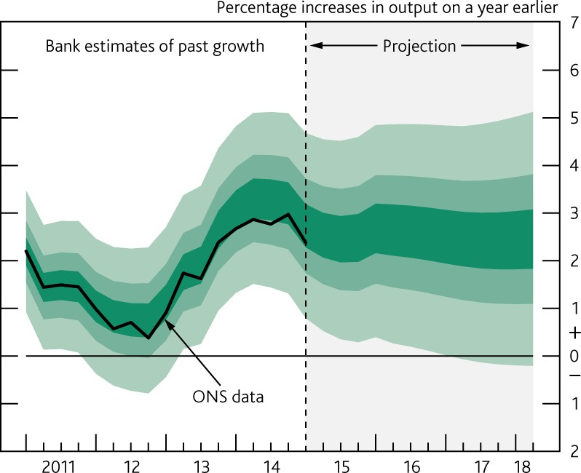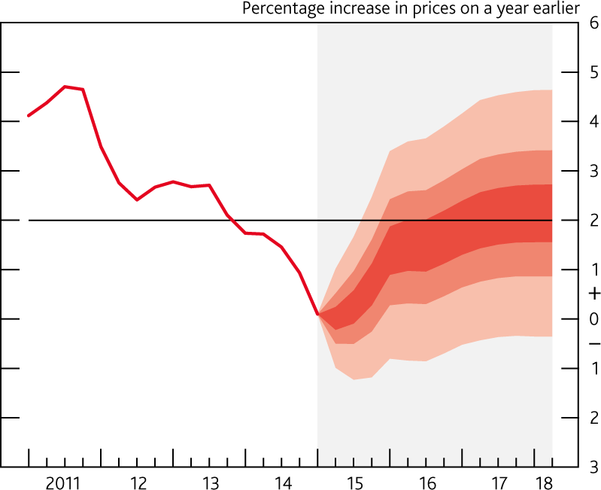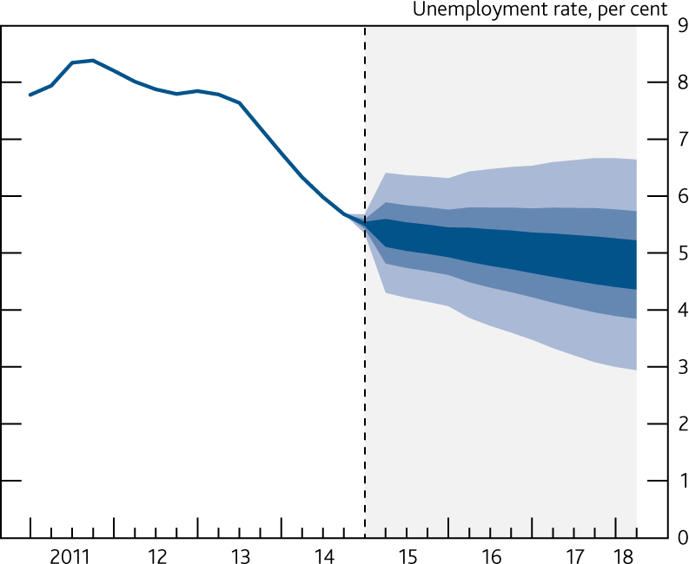

|  |  |
| --- | --- |
| **Chart 12: May IR projection for output** | **Chart 13: May IR projection for inflation** |
| See Chart 5.3 of the May 2015 Inflation Report. | See Chart 5.1 of the May 2015 Inflation Report. |
| **Chart 14: May IR projection for unemployment** | |
| See Chart 5.10 of the May 2015 Inflation Report. |  |